# Lab: Creating PizzaMore Web Site using Java, Bootstrap and CGI

This **tutorial** provides step-by-step guidelines to build a **“PizzaMore” app** in Java, HTML, CSS, Bootstrap and CGI. The app should implement **sign in** / **sing up** / **main** / **menu** pages.

## Project Specification

Design and implement a **“PizzaMore” web application** in Java, HTML, CSS, Bootstrap and CGI. Create 4 HTML pages with the following functionality:

* **Home**
  + Home page of the pizza site
  + Should be able to redirect to all other pages
  + Should send a **cookie** to the browser
  + Option to change language via **cookie**
* **Sign Up**
  + Register a new user in a the database.
* **Sign In**
  + In case of success, a session should be stored in your database.
  + Log out option that will delete the session

## Setup

* Download [**Bootstrap**](http://getbootstrap.com/getting-started/#download)and place it in **htdocs folder.**
* Download [**jQuery**](https://jquery.com/download/)and place it in **htdocs folder.**
* Create a **css folder** in **htdocs folder.**
* Create an **image folder** in **htdocs folder. Copy the images from the archive.**

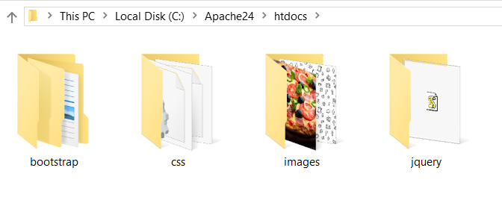

## Build Home Web Page

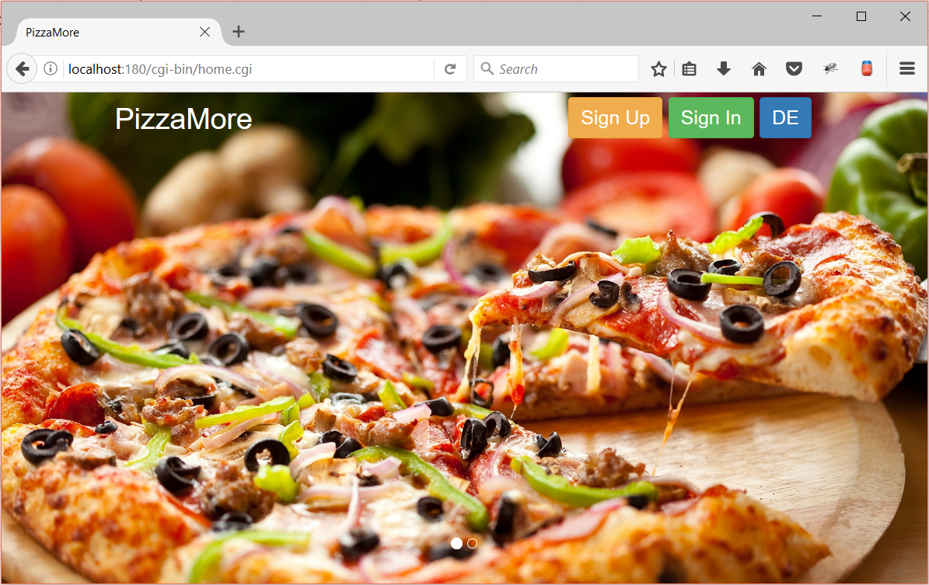

Create an empty HTML page home.html.

* The design includes two Bootstrap features:
  + Carousel
  + Navigation
* Put the required metadata in the **<head>** tag. Bootstrap link should be located there.



* Import the required JavaScript module and jQuery just above the closing **</body>** tag.



* Create a new Carousel. It main functionality will be to **slide** between pictures.



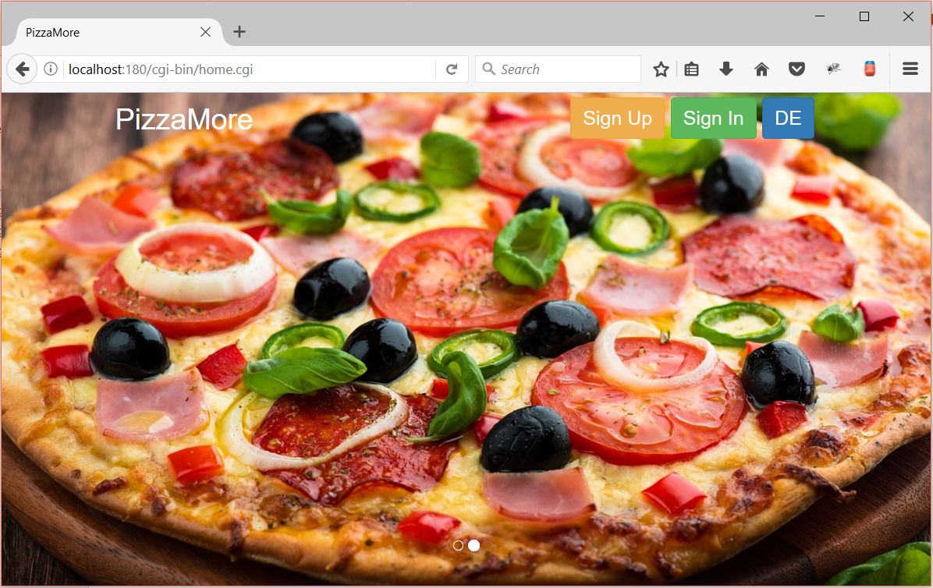



* Create a navigation with couple with 4 buttons
  + Sign Up should lead to the sign up section: **signup.cgi**
  + Sign In should lead to the sign in section: **signin.cgi**
  + EN should lead to the home section: **home.cgi** and it should change the languages of the page





* Create a file called **main.css** and put it in **htdocs/css**. The main styling of the **home** page should be there
* Make the pictures take the whole screen



* Format the navigation to be **on top of the Carousel**.



* Format the **default** **bootstrap** **settings**. Copy them from the box below.

|  |
| --- |
| **main.css** |
| .**navbar-default** .**navbar-brand** {   **color**: **#ffffff**; } .**navbar-default** .**navbar-brand**:**hover**,  .**navbar-default** .**navbar-brand**:**focus** {  **color**: **#e0e0e0**;  **font-size**: **30px**; } |

* Create a **Java** class for the cookies. It should have a method that returns the name and the value with **“=”** between them.



* Create a **Java** file Header.java. It should take care of some of the possible headers



* Create a **Java** file Home.java. It should take care of the actions in the Home page



* Then you need to read the **incoming parameters and take some actions**. Use the [WebUtils](https://softuni.bg/downloads/svn/web-development/Jan-2017/Java-Web-Dev-Basics/02.%20Java-Web-Dev-Basics-HTTP-Protocol/Utils.zip) class.



* Then we need to read the **incoming cookies:**



* The last step would be to **print the html**

|  |
| --- |
| **Home.java** |
| **private static void** readHtml() {    Cookie languageCookie;  **if** (!WebUtils.*isPost*()) {  **if** (*cookies*.containsKey(**"lang"**)) {  languageCookie = *cookies*.get(**"lang"**);  **if** (languageCookie.getValue().equals(**"DE"**)) {  *readHtmlDe*();  } **else** {  *readHtmlEn*();  }  }  } **else** {  **if** (*parameters*.containsKey(**"language"**)) {  String language = *parameters*.get(**"language"**);  **if** (language.equals(**"DE"**)) {  *readHtmlDe*();  } **else** {  *readHtmlEn*();  }  }  } }  **private static void** *readHtmlEn*(){  }  **private static void** *readHtmlDe*(){  } |

* Finally run the main method



* Create a CGI file

|  |
| --- |
| **home.cgi** |
| #!C:\cygwin64\bin\bash.exe  java -Dcgi.query_string=$QUERY_STRING -Dcgi.request_method=$REQUEST_METHOD -jar Home $HTTP_COOKIE |

## Build Sign Up Web Page

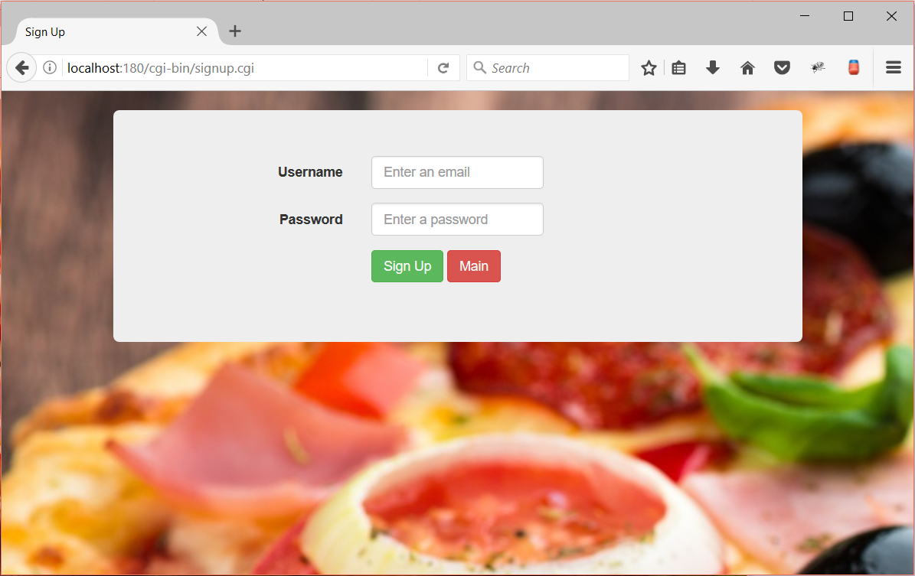

Create an empty HTML page signup.html.

* The design includes two Bootstrap features:
  + Form
  + Jumbotron
* Create the form using **Bootstrap**. Don’t forget to import the required **links**.



* Add the background image via css:



* Create **User** class



* Create user repository that will retrieve and save users



* Create SignUp java class that will **save user’s details into a database**.



* Create a method that will read the parameters



* Create a method that will create the user



* Invoke the main method



* Create a CGI file

|  |
| --- |
| **singup.cgi** |
| #!C:\cygwin64\bin\bash.exe  java -Dcgi.query_string=$QUERY_STRING -Dcgi.request_method=$REQUEST_METHOD -jar SignUp.jar |

## Build Sign In Web Page

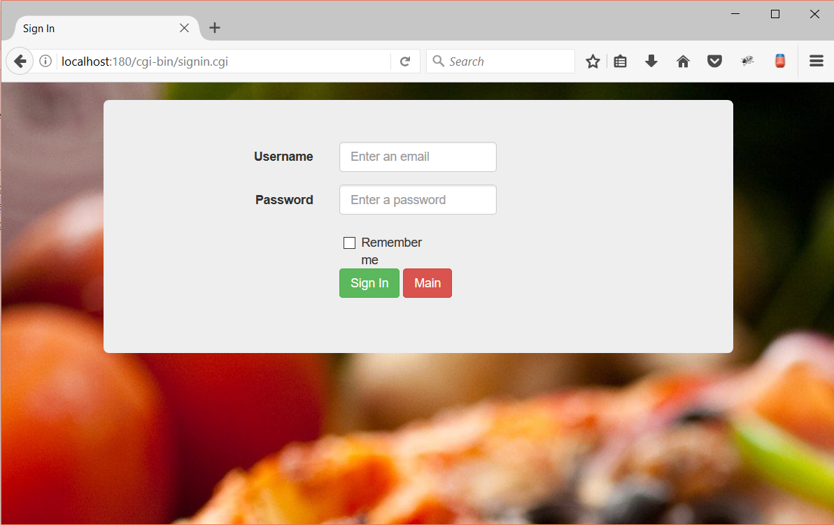

Create an empty HTML page signin.html.

* The design includes two Bootstrap features:
  + Form
  + Jumbotron
* Create the form using **Bootstrap**. Don’t forget to import the required **links**.



* Add a **background image via css** file:



* Create a java file called **SignIn.java**
  + **It should check the credentials**
  + **Create a session with them**
  + **Send the session as a cookie**
  + **When signed out the session should be deleted**
* Create a Session class



* Create Session Repository which will save and retrieve sessions



* Create a method a **SingIn** java class



* Create a method that will read the **parameters and take the necessary actions. Send a session cookie with the session id to the client.**



* Invoke the **main** method

|  |
| --- |
| **SignIn.java** |
| **public static void** main(String[] args) {  *readParameters*();  *header*.printHeader();  *readHtml*(); } |

* Create a CGI file

|  |
| --- |
| **signin.cgi** |
| #!C:\cygwin64\bin\bash.exe  java -Dcgi.query_string=$QUERY_STRING -Dcgi.request_method=$REQUEST_METHOD -jar SignIn.jar |

## Read Session from Home Page

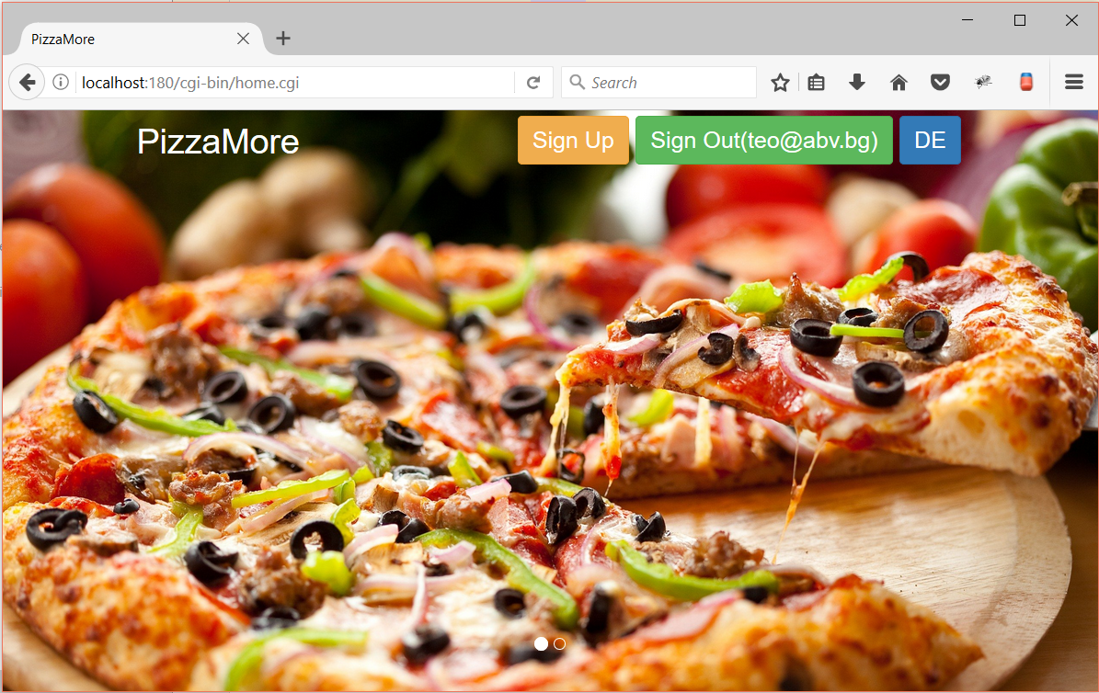

We need to update our home page and make it read session cookies

* Update **Home.java**

|  |
| --- |
| **Home.java** |
| **private static** SessionRepository *sessionRepository*;  …  **static** {  *…*  *sessionRepository* = **new** SessionRepository(); } |

* Read the **session cookie and add change the Sign In button to Sign Out**

